Question 26:

CODE:

%{

#include <stdio.h>

int c_count = 0, l_count = 0, w_count = 0;

%}

%%

. { c_count++; } /* Count characters */

\n { l_count++; } /* Count lines */

[ \t]+ { /* Ignore spaces and tabs */ }

[a-zA-Z0-9_]+ { w_count++; } /* Count words */

%%

int main() {

yylex();

printf("Characters: %d\nLines: %d\nWords: %d\n", c_count, l_count, w_count);

return 0;

}

int yywrap() {

return 1;

}

OUTPUT:

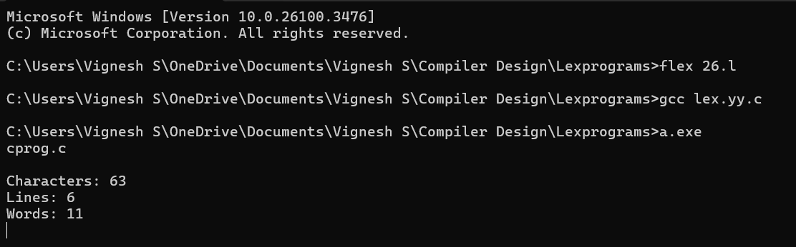

Question 27:

CODE:

%{

#include <stdio.h>

%}

%%

[0-9]+(\.[0-9]+)? { printf("Constant: %s\n", yytext); } /* Match integers and floats */

.|\n { /* Ignore everything else */ }

%%

int main() {

yylex();

return 0;

}

int yywrap() {

return 1;

}

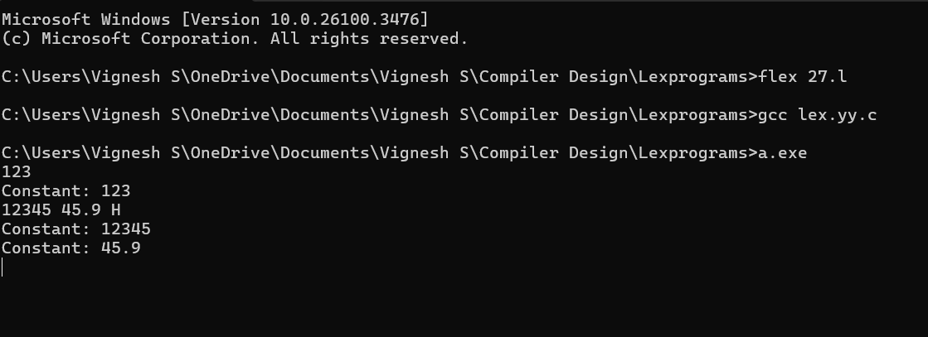

Question 28:

CODE:

%{

#include <stdio.h>

int macro_count = 0, header_count = 0;

%}

%%

^#define { macro_count++; }

^#include { header_count++; }

.|\n { /* Ignore everything else */ }

%%

int main() {

yylex();

printf("Number of Macros: %d\nNumber of Header Files: %d\n", macro_count, header_count);

return 0;

}

int yywrap() {

return 1;

}

OUTPUT:

